**Steps to Create Request to Migrate Servers to New Centrify Zones**

**1.** Goto <https://jnjprod.service-now.com/iris> and click on “**IT Service Item Catalog**”

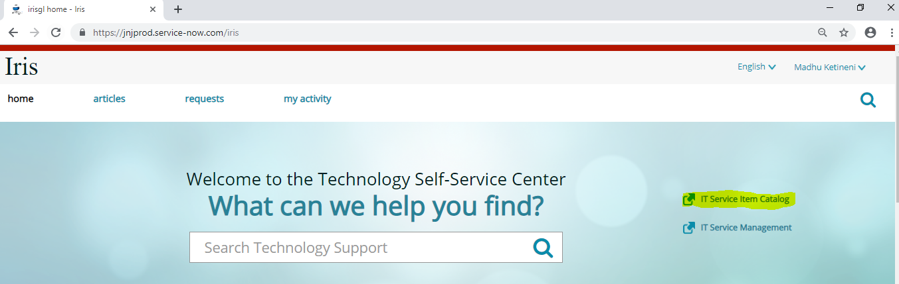

**2.** Select the tab “**Submit a request**” and click on “**Server provisioning and support**”

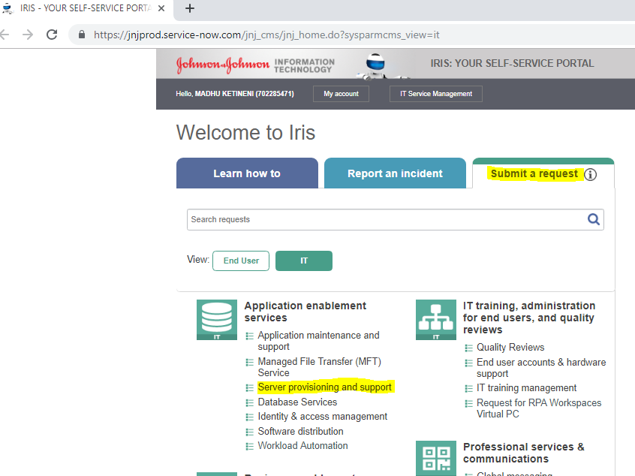

**3.** Click on “**Server Change and Maintenance**”

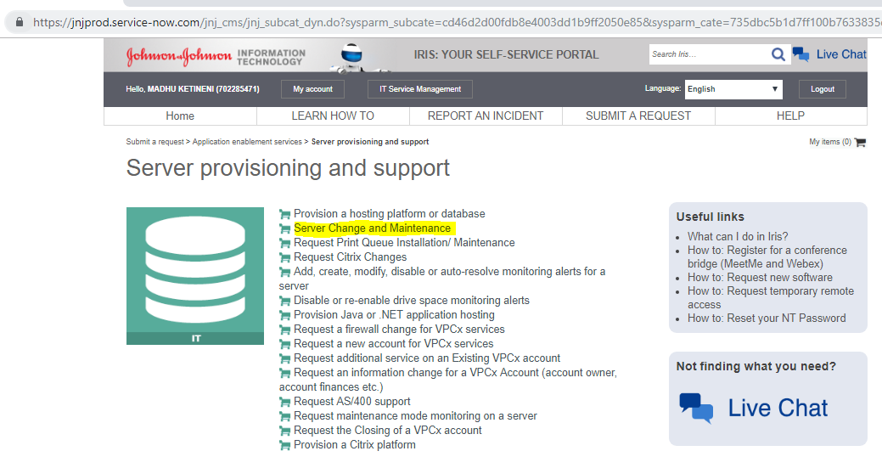

**4. Select or enter the required information on the next screen as shown below.**

* Select appropriate application associated with the server under “Select Application / Application Server”.
* Select the server on which the change/maintenance is required under “Select Server”.
* For Type of Activity select “Update CMDB”.
* Select Maintenance Start and End Date/Time.
* In Business Reason (Justification) describe what servers needs to be added to what zones and any other relevant information.
* Enter Technical Impact same as Business Reason (or enter the actual impact)
* Select appropriate Business Impact.

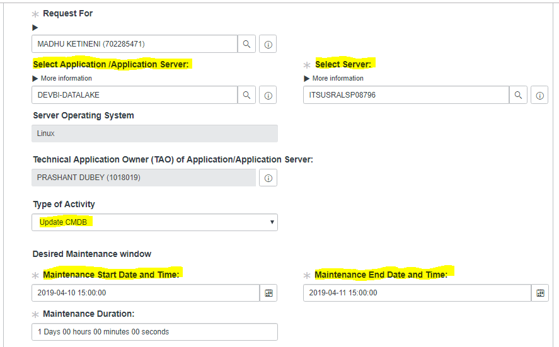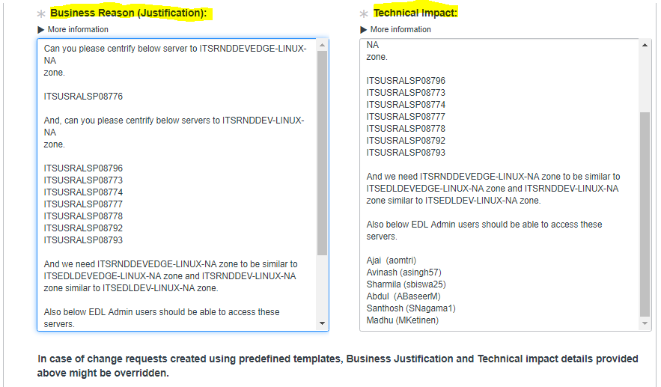

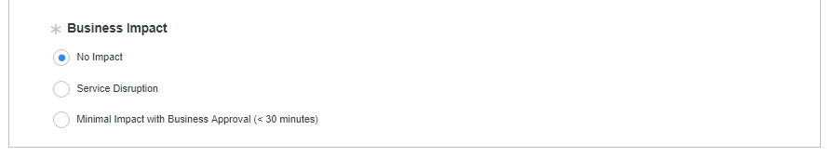

**5**. Click on “**Choose Options**” on the top right side of the screen.

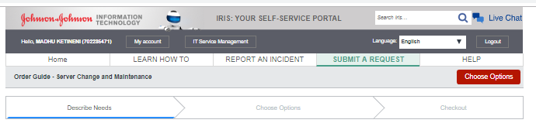

**6.** On the next screen

* Select **“Yes”** for Add More Servers.
* In **Select Additional Servers** search for all the servers impacted by this change and move them to the “**Selected**” column one at a time.
* For **“CMDB update request description”** enter same information as entered in Business Justification field in Step 4.

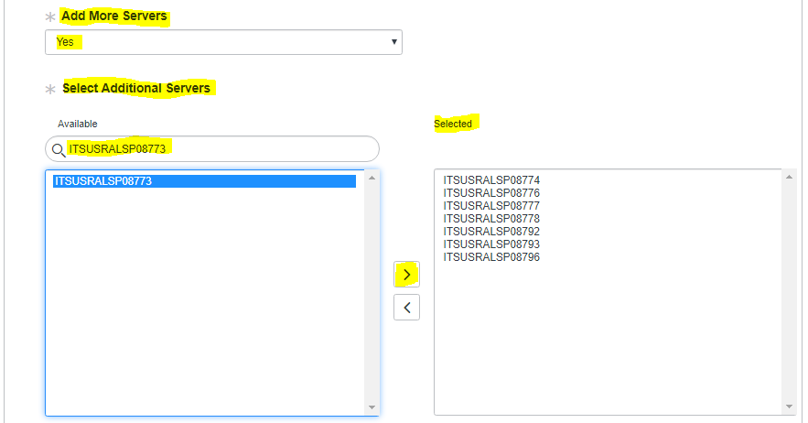

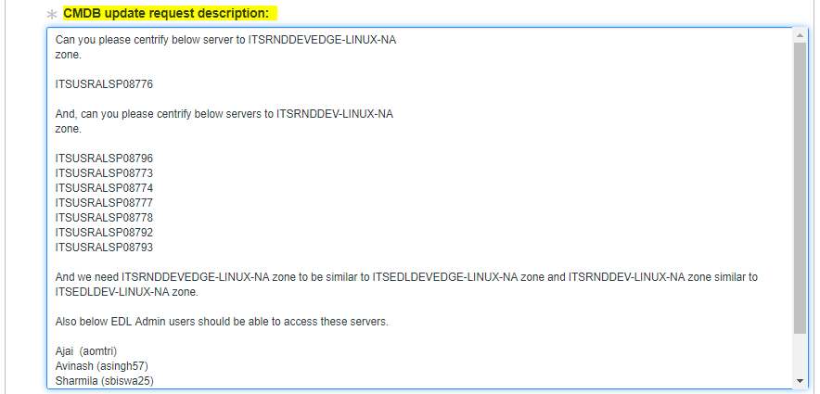

**7.** Click on “**Checkout**” on the top right side of the screen and the request will be submitted. Note down the Request number for reference.

